14.90: When the level of the water is a height y above the opening, the efflux speed is 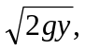 and 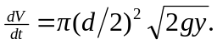 As the tank drains, the height decreases, and
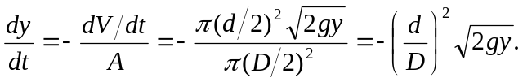
This is a separable differential equation, and the time T to drain the tank is found from
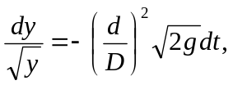
which integrates to
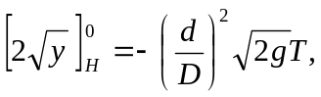
or
